Parents,

Welcome to the DYA (Team Name) softball for (Coach Pitch, Minors, Majors, Seniors) grades (1st & 2nd, 3rd &4th grade, 5th & 6th grade, 7th – 12th grades). I am your coach xxx and my Assistant Coach is xxxx. We look forward to a great season. Our goal is to have fun with the girls while they learn the skills and fundamentals of softball.

Following is league information that you may find helpful.

Equipment and uniform:

LEAGUE PROVIDES: Visors are provided with league fees. DYA Jerseys can be purchased through DYA (contact the DYA office via email if you want to purchase a set of jerseys).
- Batting helmets – 4 per team
- Game balls
- Practice balls
- Catcher’s Gear
- Infielder face mask – 2 per team

ITEMS TO BE PURCHASED OUTSIDE OF DYA:
- Softball pants (color to be determined by Coach) white, black, or gray
- Softball glove
- Socks
- Softball bat (see how to buy a softball bat for more information) – we encourage sharing of bats to those who may not have one
- Tennis shoes or softball cleats (no metal cleats)
- Some girls/parents prefer to have their own batting helmet and infielder face mask which is their discretion

If you choose to buy a bat, here is a page on suggestions on buying a bat - http://protips.dickssportinggoods.com/sports-and-activities/softball/buy-youth-softball-bat

Please note; the league requires the girls to wear softball pants so the girls are able to slide. We will provide coupons to Dick’s Sporting Goods.

Important Dates:
- Game schedules are expected ready by mid April
- Games will begin about May 6 and go until about July 1
- Tournament will begin about July 5 – July 15
- Double header Saturday June 10, 17, or 24
- Picture day is the first Saturday game scheduled for your team

DYA All-Star Teams
Coach Pitch and Minors: All-Star team tryouts tentative May 20 with one or two tournament games in July (TBD).

Majors and Seniors: All-Star game Saturday 7:00pm July 22.

DYA CLINICS AT MANNINO’S –

DYA has significantly reduced rates for the following special DYA clinics at Mannino’s on Sawmill:

Amber Curry will be leading the Pitching Clinics for DYA Rec softball players. Amber pitched at Ohio Dominican University after years of working with our very own Les Randolph. She has been teaching pitching at Grand Slam for the past 2 years. Alyssa Kelley, GLIAC Player of the Year, will be instructing the Hitting. Coach Kelley went on to Coach College ball before landing as the Head SB Coach @ Jerome HS. This camp will be a great opportunity for both beginning and experienced players to learn new skills and work on perfecting their fundamentals and mechanics. Each girl will be able to take the skills learned here to practice, both with their team and at home.

All sessions will be held at Mannino’s Grand Slam.

Register online – click the following links or call 614-717-9934

http://www.grandslaminfo.com/softball/camps/157/dyaoyaa-softball-spring-pitching-clinics/ - click here to register for pitching clinics

http://www.grandslaminfo.com/softball/camps/156/dyaoyaa-softball-spring-hitting-clinics/ - click here to register for hitting clinics

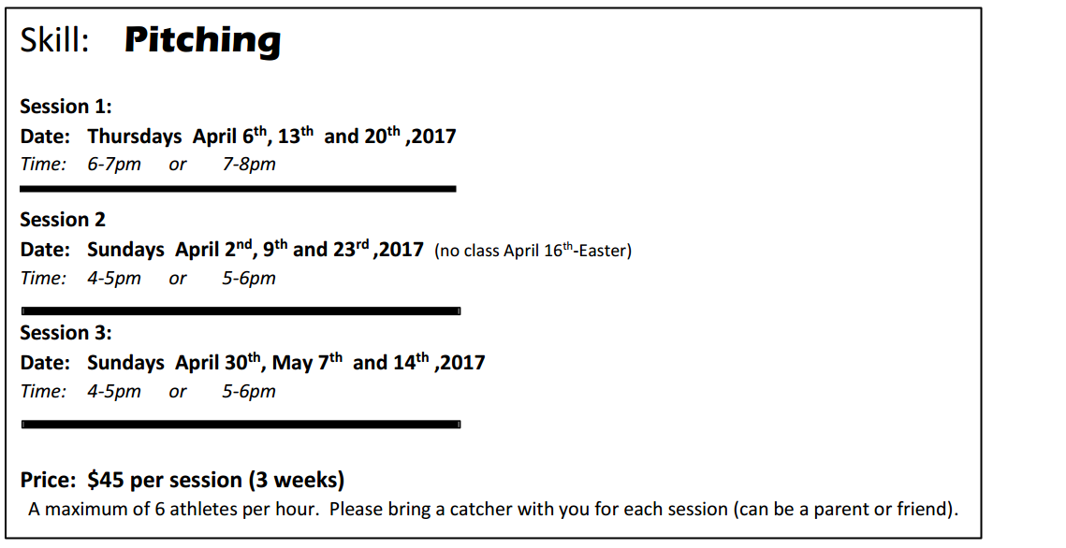

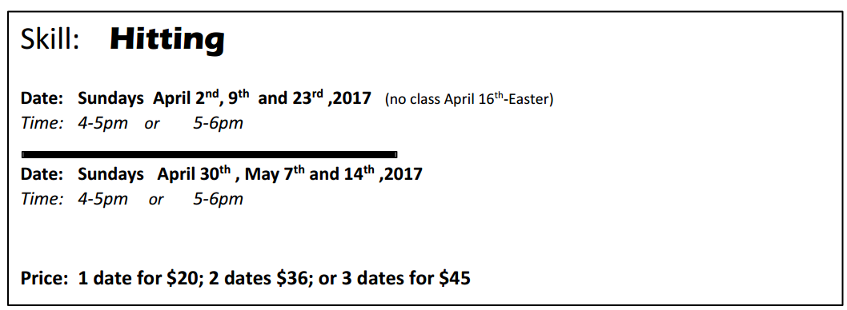

*** If your daughter wants to pitch, we highly recommend to sign up for at least a 3 week small group session to learn fundamentals or to refresh their skills if they've pitched in the past.

Please let me know if you have any questions.

Thank you.

XXXXXXX

