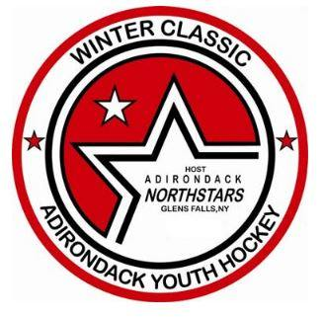
Adirondack Northstars Winter Classic XXIV
January 12-15, 2018
APPLICATION FORM

Team Name: ___________________________________

Division (mark one): □ 10U (Atom B/C)
□ 12U Rec (PeeWee C/House)
□ 12U Tier II (PeeWee B)
□ 14U Rec (Bantam C/House)
□ 14U Tier II (Bantam B)
□ 16U Rec (Midget C/House)
□ 16U Tier II
□ 19U Tier II (Midget B)

**Tournament Committee will work with Canadian teams for best placement**

Contact Name: _________________________________________

Address: __________________________________________

__________________________________________

Cell number: (_____) ____________________ E-mail Address: __________________________________

Home Jersey Color: _____________________ Away Jersey Color: ______________________________

E-mail application to: michele.hunter00@gmail.com (preferred)

Or mail to: Michele Hunter
1351 Coach Rd.
Argyle, NY 12809

• Entry Fee: $900.00
• 3 game minimum
• Teams will be notified of acceptance after divisions have been determined.
• Please do NOT send rosters and/or entry fee until your team has been notified of final acceptance into the tournament.
• All teams must be registered with USA Hockey or Hockey Canada (Official USA Hockey or Hockey Canada rosters must be presented upon sign-in, prior to first game).
• For questions or further information, please contact:
Michele Hunter
Winter Classic XXIV Tournament Director
michele.hunter00@gmail.com
(518) 232-0890

