Nipmuc Youth Softball Covid-19 Code of Conduct
Revised July 27, 2020
**************************************************************************************************
Revised July 27, 2020 in response and accordance with, Massachusetts COVID-19 Order No.43 Amended on July 24,2020.
**************************************************************************************************
Revised procedures related to amended policy:
Game-Play (Competition) revisions:
Each player will be required to wear a face covering when not actively playing a defensive position. Including, batters, runners and any players on the bench, on deck, etc. Facemasks should be kept with each player’s personal equipment (helmet, bag, bat, etc.) when playing a defensive position.
**Please note: this ONLY applies to multi-team competition. i.e. Games, scrimmages with other teams. This does NOT apply to practices with less than 25 participants**
Player drop off: Players are not permitted arrival prior to 45 minutes before game start. Spectators are permitted in appropriate areas no more than 10 minutes prior to game start time.
Game Parking: The Home team (Nipmuc) at Memorial Field should park in the Taft Ave. parking lot at the town beach.
The Visiting Team should part on the Millville Rd. parking lot and shared baseball lot. This will avoid spectators, players and coaches from walking behind the backstop. This area is off limits at all times to non-participants of the game.
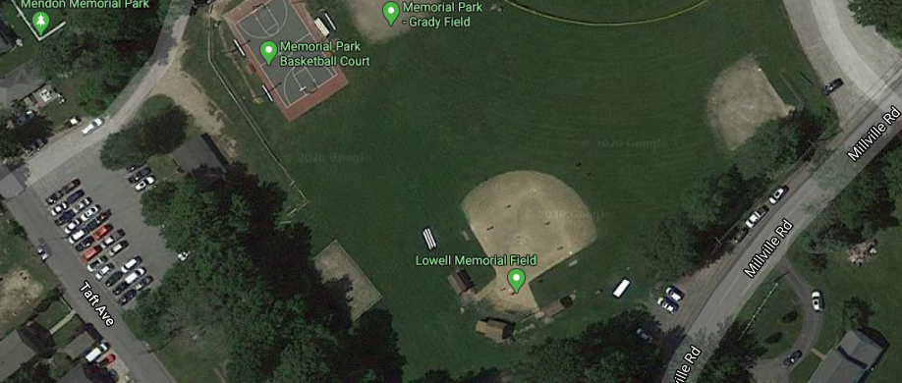
Visitor Team Parking
Home
Team
Parking
---End revision notes
Overview
Outlined in this document are the specific rules, plans and suggestions to provide a safe environment for our players, coaches and spectators. These have been derived from guidance provided by USA Softball, Commonwealth of Massachusetts, WHO, CDC as well as the best intentions of the NYS board.
Failure to follow these rules will result in removal from the field area, up to and including the parking lot.
Repeated violations may result in removal from NYS for the season

Players, coaches and spectators alike are responsible to ensure these guidelines are followed for the safety of all involved. Please note: if umpires are at the game, they will not be responsible for these safety guidelines, other than their own PPE.
These guidelines are expected to be in place for the entirety of 2020 for practices, scrimmages, games, tournaments and any other league event in Massachusetts. Other states may have different guidelines and they should be reviewed prior to play at these locations.
Hand sanitizer and cleaning agents will be provided by NYS. This may be used several ways.
- Each player is expected to use hand sanitizer at the beginning of practice and/or game and periodically throughout practice and/or game.
- No more than 25 participants on the field at any one time. Limit groups to 10 participants max. (i.e. half team and coach at batting cage and balance on the field).
- Each player is expected to use hand sanitizer upon returning into the dugout area after playing defense, as well as after batting/running.
- Balls used within the playing area and/or practice will be sanitized by using a cleaning agent on a regular basis.
- Catchers equipment will be sanitized when used between multiple players, however, it is strongly encouraged catchers have their own equipment.
- Each player will be expected to use hand sanitizer upon request of the Safety Monitor i.e. touching your face.
- All coaches, monitors and players may be required to sign a COVID waiver.
Safety monitor
Each team will have a designated safety monitor (parent volunteer) during practices in order to ensure players are following the guidelines. This person will be identified prior to the practice/game, it is expected the safety monitor will undergo USA Softball background checks and will stay outside of the dugout area. This person can guide others to properly distance, wear masks, use hand sanitizer, wipe equipment, etc. from outside the temporary fencing. This will allow for as few people inside the dugout area and reduce the distancing constraints within the set area.
Distancing
NYS will make efforts to mark suggested locations for participants and spectators.
- No more than 25 participants on the field at any one time. Attempt to limit groups to 10 participants max. (i.e. half team and coach at batting cage and balance on the field or half the team inside dugout and half behind dugout).

CPR
Good Samaritan laws still protect by standers to help anyone whom requires. Various medical organizations recommend chest compressions only during this pandemic. One-way valves should be used always but can add as a barrier even if chest compressions are only used.
NYS has one – way breathing valves attached to each AED located at each field. This valve will cover the face of the person at harm and will help protect from airborne transmission.
Players
Social distancing should be maintained when not actively playing on the field. All other players should be behind the wooden dugout in the fenced off area. All players in this area should maintain six (6) feet apart and wear a face covering.
Face covering
Face coverings are required for players not in the field defensively. Including at bat, running the bases, coaching the bases, in the dugout, on deck, etc.
Face coverings are not required when actively playing defense, catchers are NOT required to wear a face covering under her mask. Players should bring an individual bag to place her covering in while not wearing it. Please label your bags/coverings.
Water bottles
No shared containers. It is expected each player brings her own water bottle if desired. Any water bottle not labeled will be thrown away by the safety monitor to avoid cross contamination.
Food
Only prepackaged foods allowed during games. No food allowed during practices due to the short time on the field. Exception may for medical reasons, please advise your coach prior to practice/season.
Foods that encourage spitting are not allowed. Sunflower seeds as an example are not permitted while at the field, stands nor parking lot.
Equipment
No shared equipment. Players are expected to bring their own gear that is clearly labeled, including but not limited to: helmets, glove, batting gloves, masks, catchers gear, face covering, cleats, etc.
Coaches
Face covering
Required at all times.
Social distancing is encouraged. In the event of a team huddle, the coach should stand in the middle of the team while maintaining 6 feet apart.

Spectators / Visiting teams
Required to wear masks at all times and socially distance. No spectators are allowed behind the dugout area
Practice Drop off: Parents should remain in their vehicles and drop off their child no more than 10 minutes prior to start of practice.
Player drop off: Players are not permitted arrival prior to 45 minutes before game start. Spectators are permitted in appropriate areas no more than 10 minutes prior to game start time.
Game Parking: The Home team (Nipmuc) at Memorial Field should park in the Taft Ave. parking lot at the town beach.
The Visiting Team should part on the Millville Rd. parking lot and shared baseball lot. This will avoid spectators, players and coaches from walking behind the backstop. This area is off limits at all times to non-participants of the game.
Players and coaches ONLY
Visitor Team Parking
Home
Team
Parking
Games: spectators will be required to stay outside 1st / 3rd base along the outside of playing area. Spectators are required to socially distance by 6 feet as well. In the event there is an outfield fence, around the outside of the outfield fence is a suggested viewing location. The bleachers will be off limits during this time.
Concessions
NYS will setup tents within the spectator permitted areas to sell prepackaged food and drink.

Reference Materials:
https://www.mass.gov/doc/may-1-2020-masks-and-face-coverings/download?_ga=2.266230922.465427257.1591110991-777078790.1584564310

