NYS Website Functionality for Coaches – 20190405

Below is a list of basic technical functionality provided to coaches by NYS. Please contact Patrick Klupa (NYS Website Coordinator; pklupa@nipmucyouthsoftball.com) if you have any questions.

Where is Your Team Website?
- Go to www.nipmucyouthsoftball.com.
- Click the Login button in the top right corner and log in.
- Click the Teams link on the left menu.
- Pull down on the drop down menu that says Board Meetings and change to NYS Spring Season.
- Click on your team.
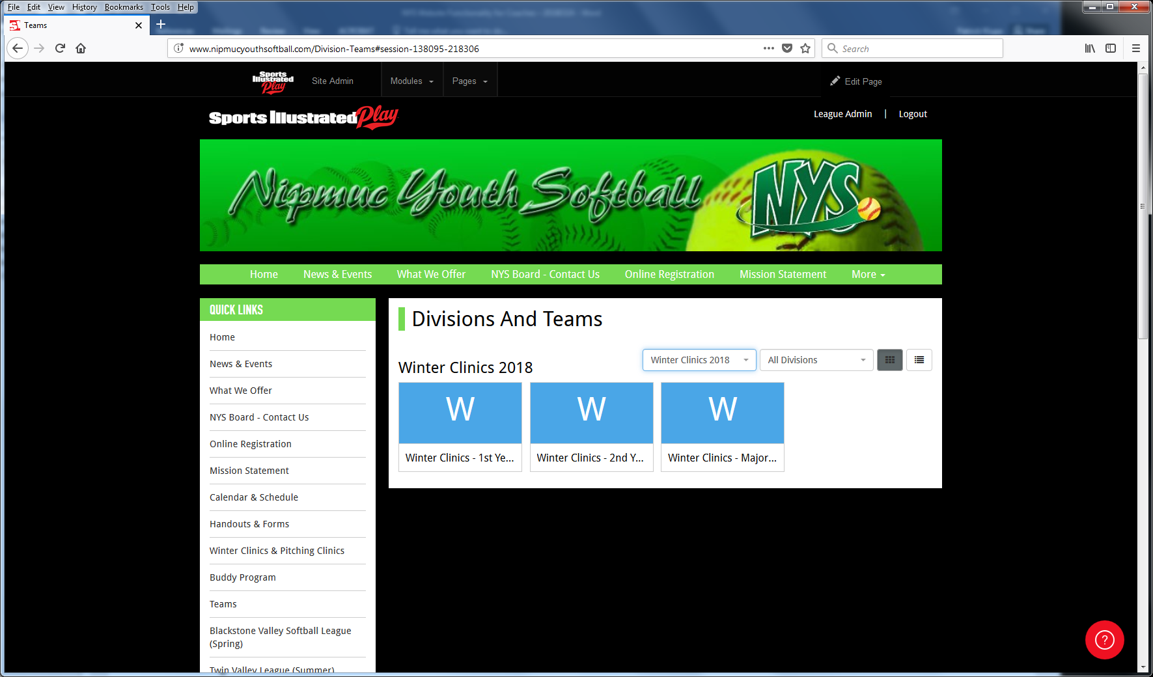

- Team website is below. You can bookmark the URL so you can navigate directly to it in the future.
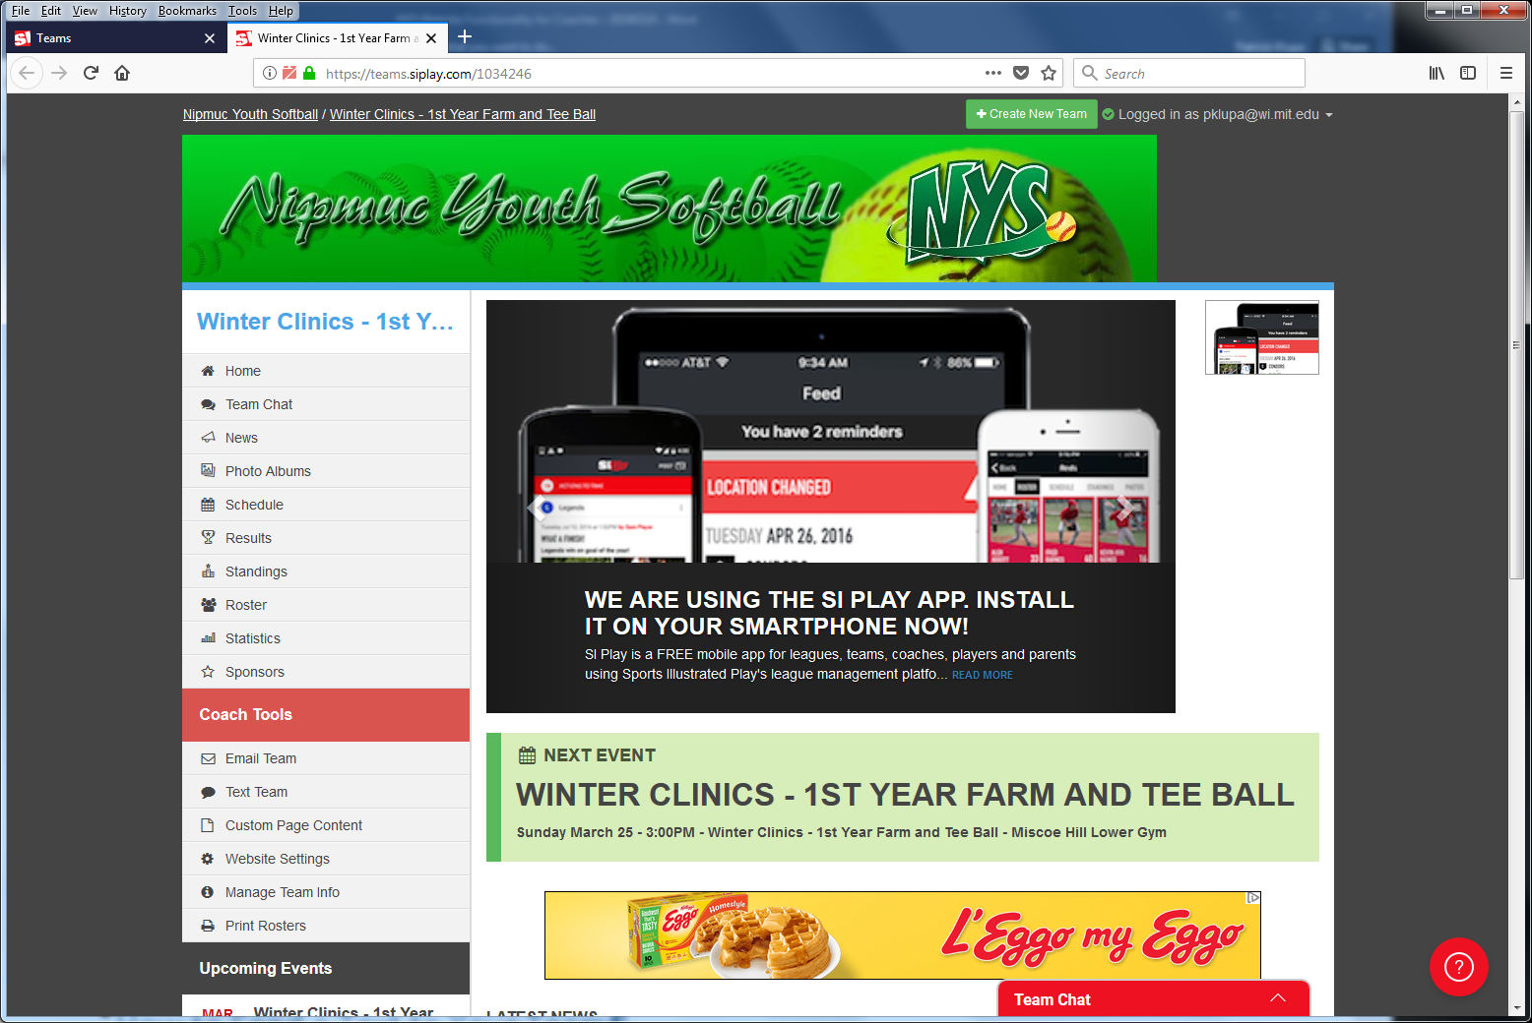

Where can I see my team’s schedule and roster (including contact info)?
There are two places where you can see your team’s schedule and roster (including contact info).

- The team website.
  - Go to the team website (see FAQ above for instructions to navigate there).
  - Click the Schedule link on the left menu (circled below). Click the dropdown arrow on the right of the event for location, attendance, and other info.
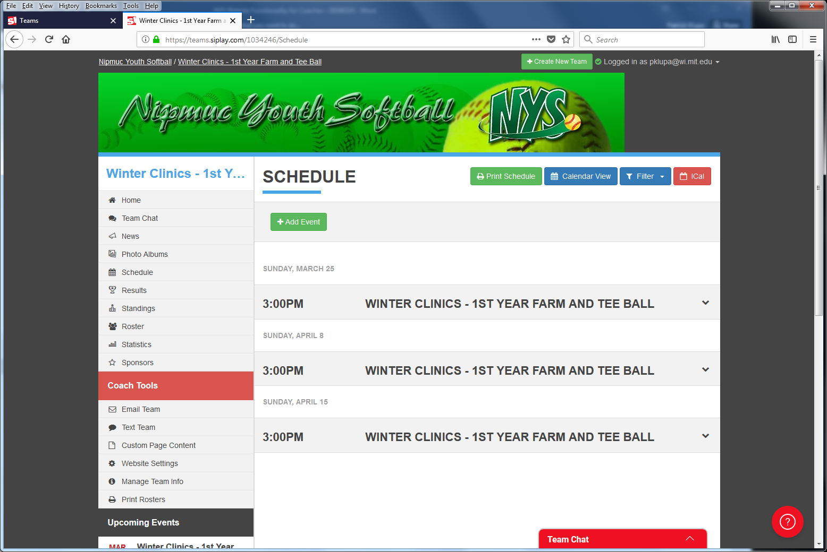
  - Click the Roster link on the left menu (circled below). Click each person’s hyperlink for contact info.
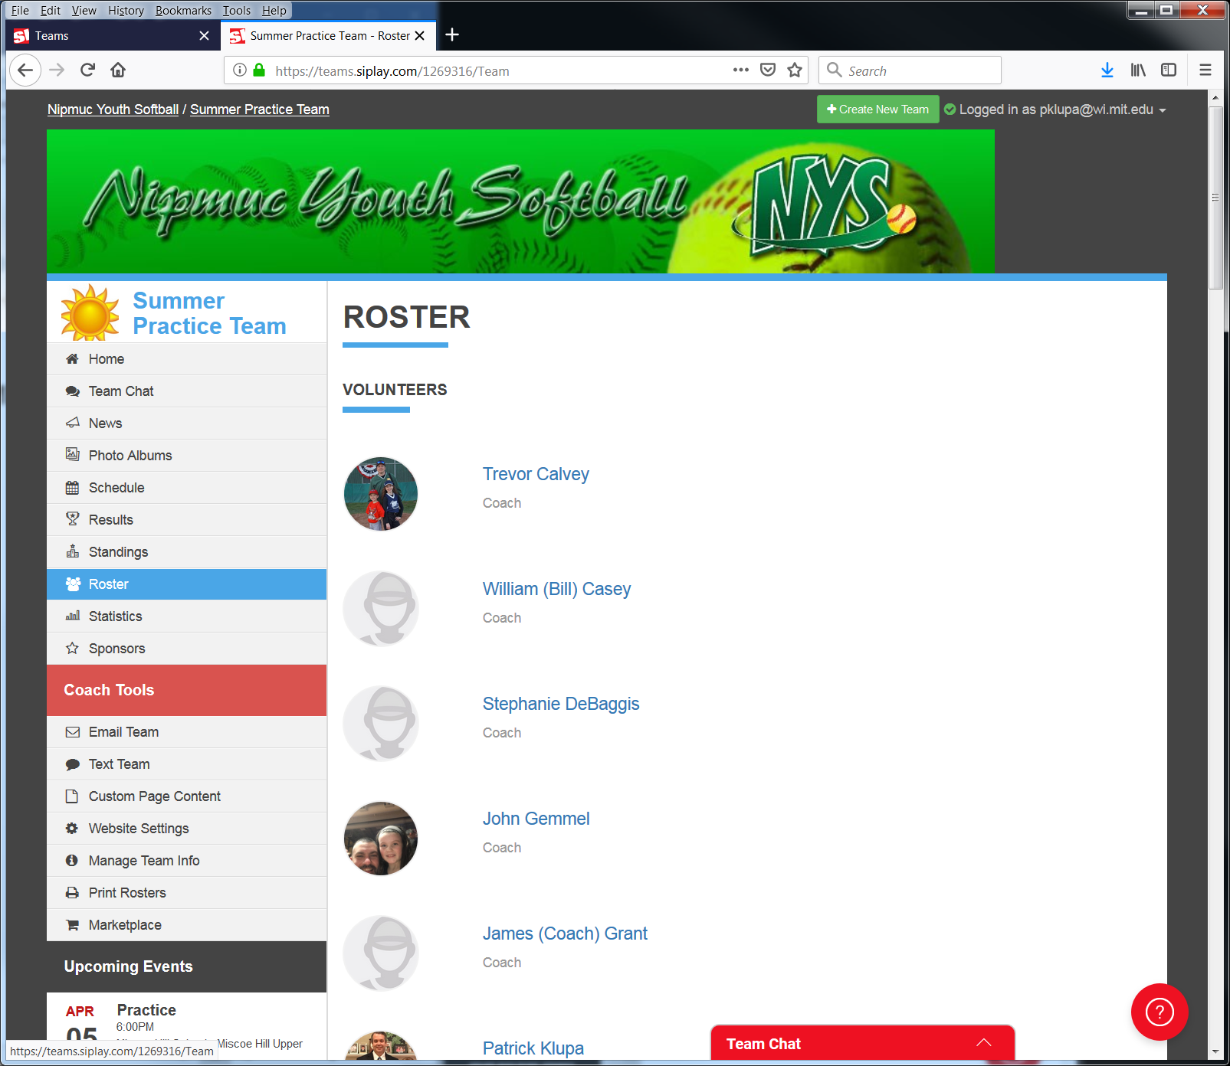

- The SI Play app.
  - Download and install the app.
  - Log into the app.
  - Click My Teams on the bottom bar.
  - If you have multiple teams, they will appear as a horizontal scroll across the top. Select the team you want.
  - Click Roster or Schedule menu items on the top to see that team’s roster or schedule.

How do I request a schedule change (games/practices/events)?

Please contact Patrick Klupa, the NYS Scheduler as far in advance as possible.
- E-mail is best – pklupa@nipmucyouthsoftball.com.
- Cell/text – (617) 230-7134.

Please see the “How to see what fields are scheduled when?” section to see what fields are available if you want to add a game/practice/event.

How do I cancel a game due to weather?

Please see the “How do I cancel a game?” procedure on the NYS FAQ page (http://www.nipmucyouthsoftball.com/FAQ).

Where can I see the Calendar of Games/Practices/Events for NYS?
- Go to www.nipmucyouthsoftball.com.
- Click “Calendar & Schedule” on the left side.
- The top panel will be NYS League Calendar.
- Select between Week, Month, and Agenda to see all of the games, practices, and events for NYS on each day.

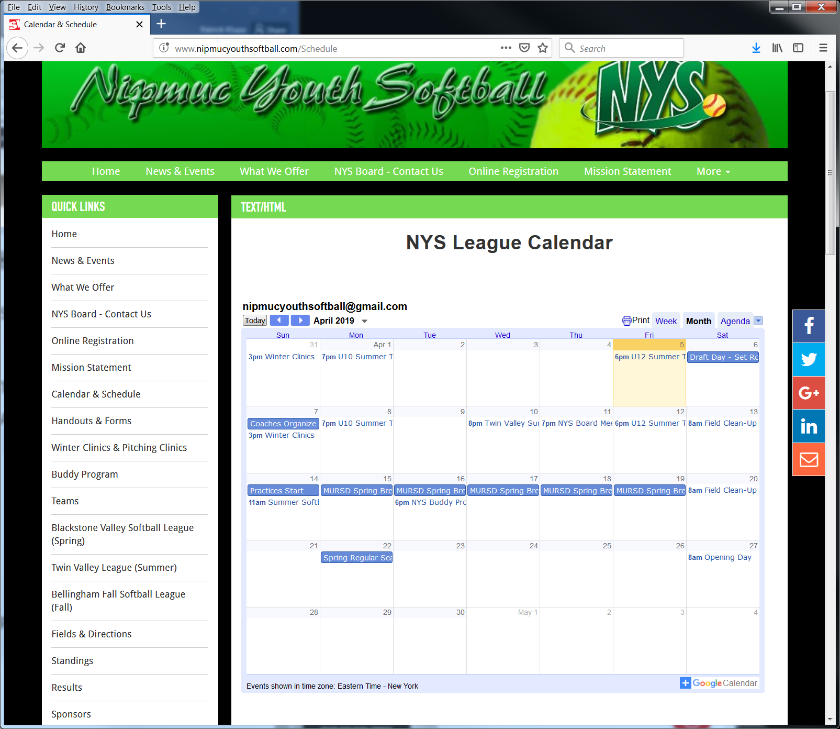

How to see what fields are scheduled when?
- Go to www.nipmucyouthsoftball.com.
- Click “Calendar & Schedule” on the left side.
- The second panel will be NYS Field Schedule. This is directly below the NYS League Calendar.
- This is an embedded Google Sheet that is the system of record for field scheduling at NYS.
- The scroll bars are a little funny – be sure to slide the horizontal scroll bar over to the right to expose the second vertical scroll bar, which allows you to see more events into the future.
- Please contact Patrick Klupa to add/move/cancel a practice. E-mail is pklupa@nipmucyouthsoftball.com. Cell/text is (617) 230-7134.

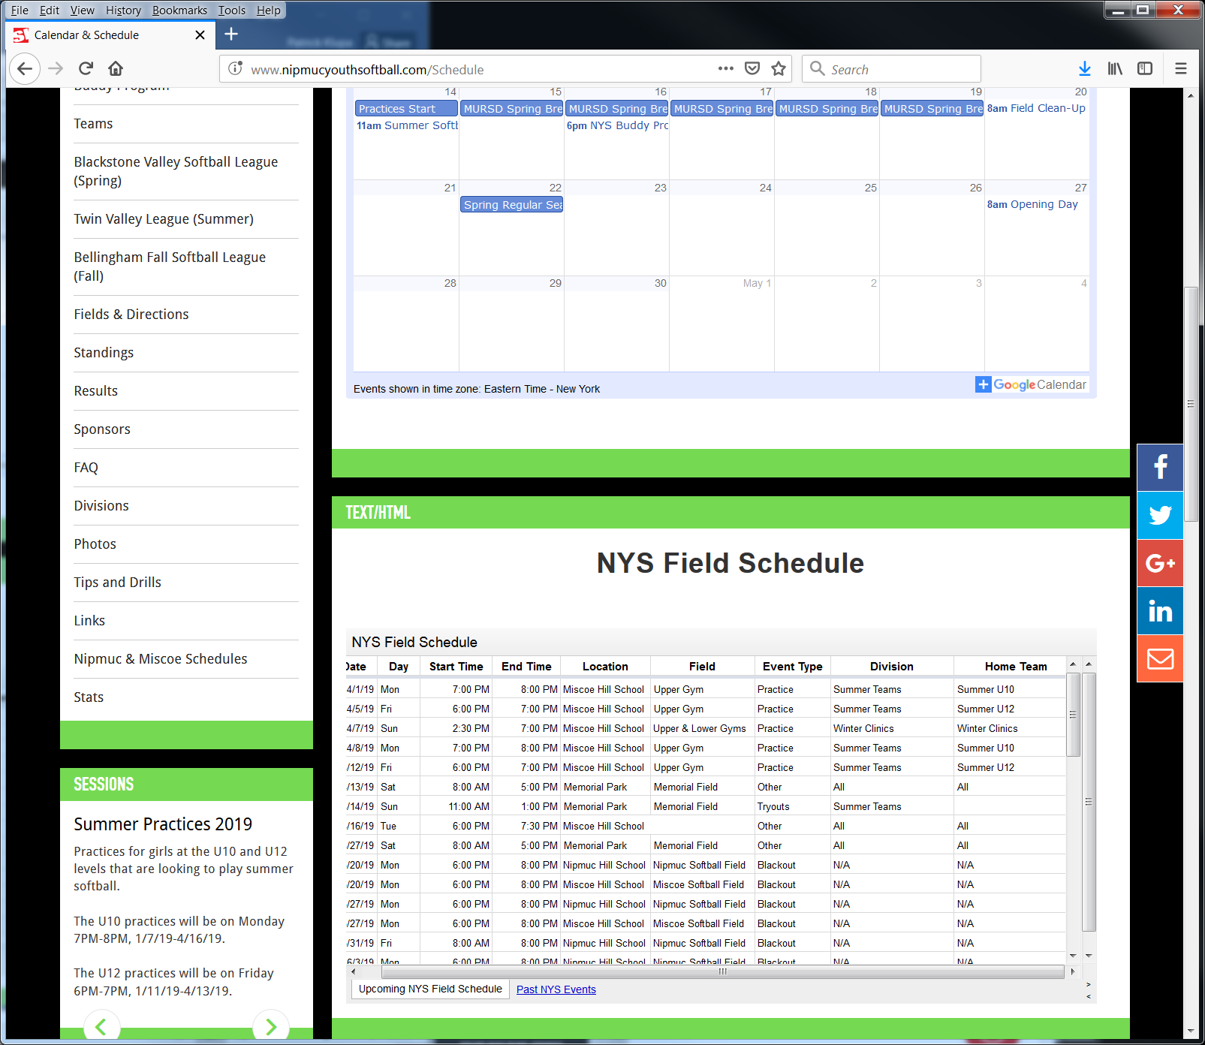

How to Send a Text to Your Team
There are two ways to send a text to your team. Please remember that parents need to opt into texting (see below) to receive texts. Otherwise the texts are sent as e-mails.

- Texting via the team website.
  - Go to the team website.
  - Click the Text Team link on the left menu (circled below).
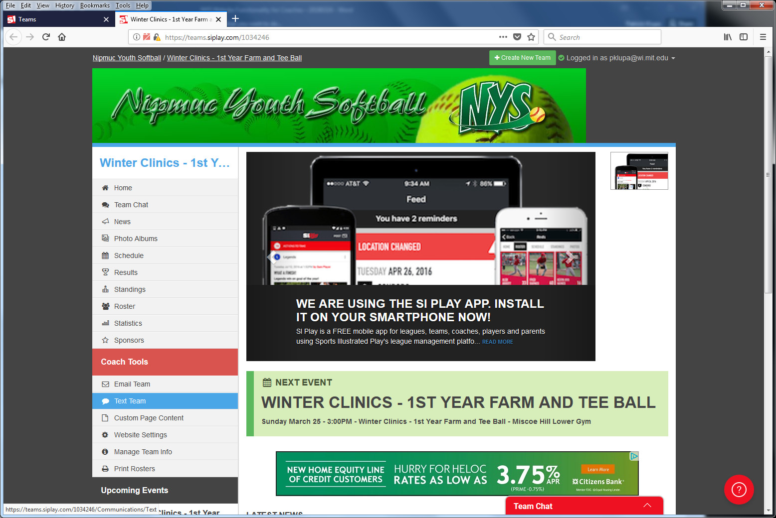
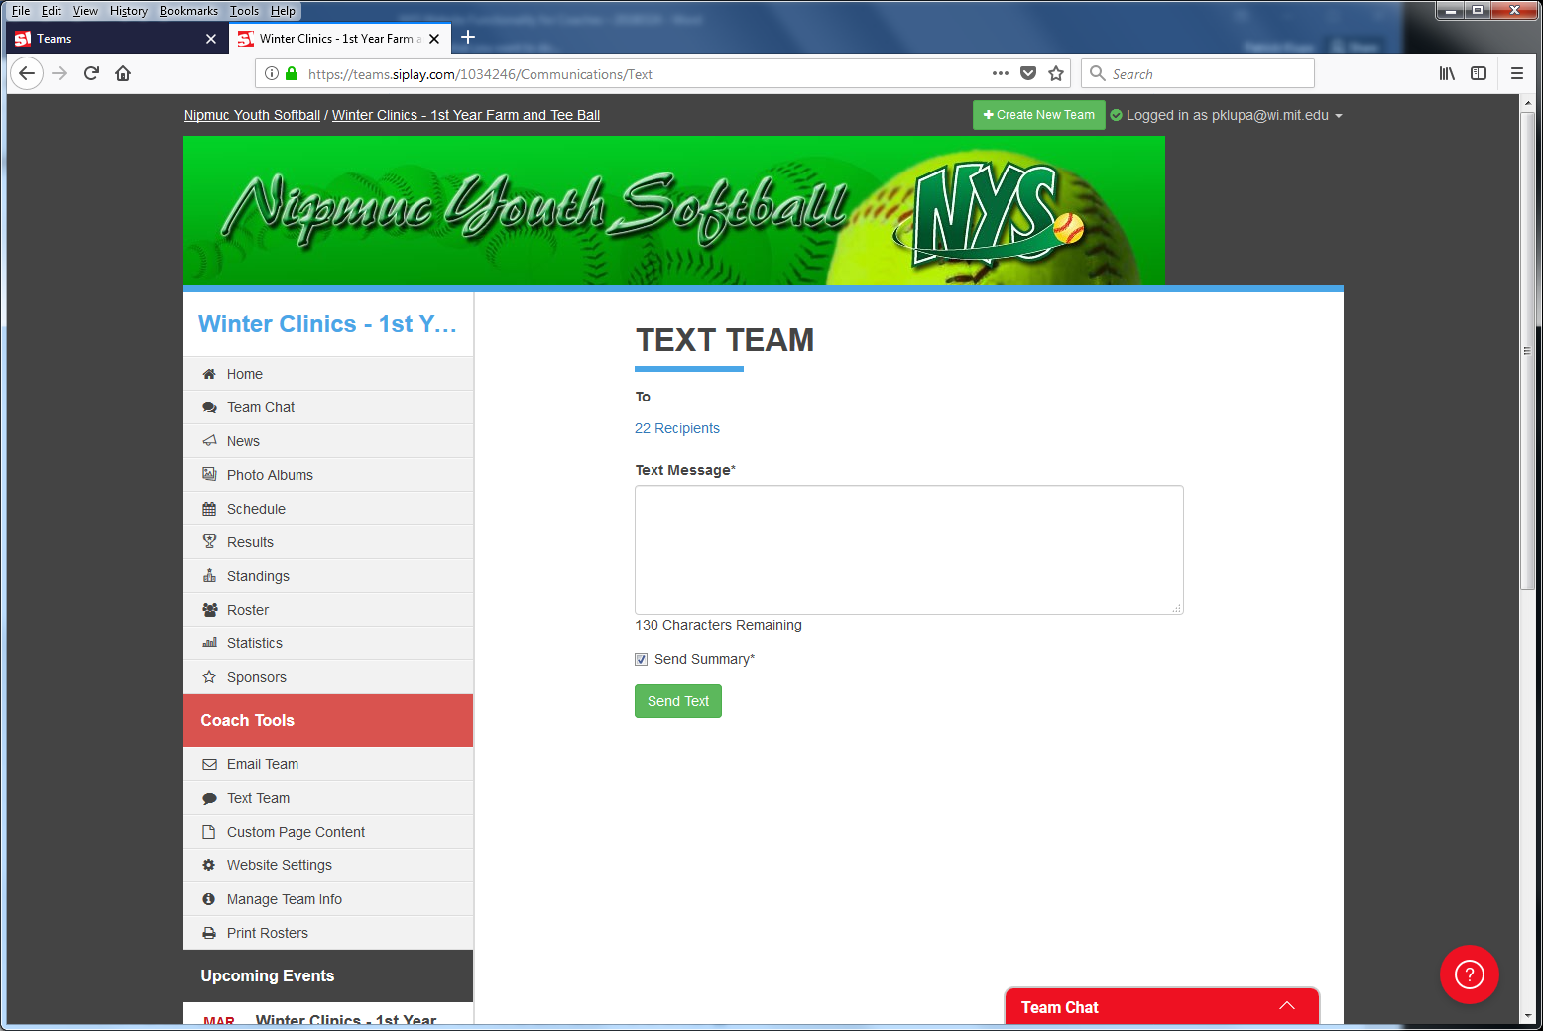

- Texting via the SI Play app.
  - Download and install the app.
  - Log into the app.
  - Click Messages on the bottom bar.
  - Select your team from the list of teams shown.
  - Click the “Send easyAlert” link in the top right.
  - A place to enter your message is shown. By default it will be sent to the entire team. Click the “+” button to add/remove individual players.
  - Click Send.
  - Please note: This method will send the message as both a text and an e-mail.

How to Send an E-Mail to Your Team
- Go to the team website.
- Click the Email Team link on the left menu (circled below).
- A place to enter your e-mail is shown. By default it will be sent to the entire team. Click the recipient list to add/remove individual players & coaches.
- Click Send Email.
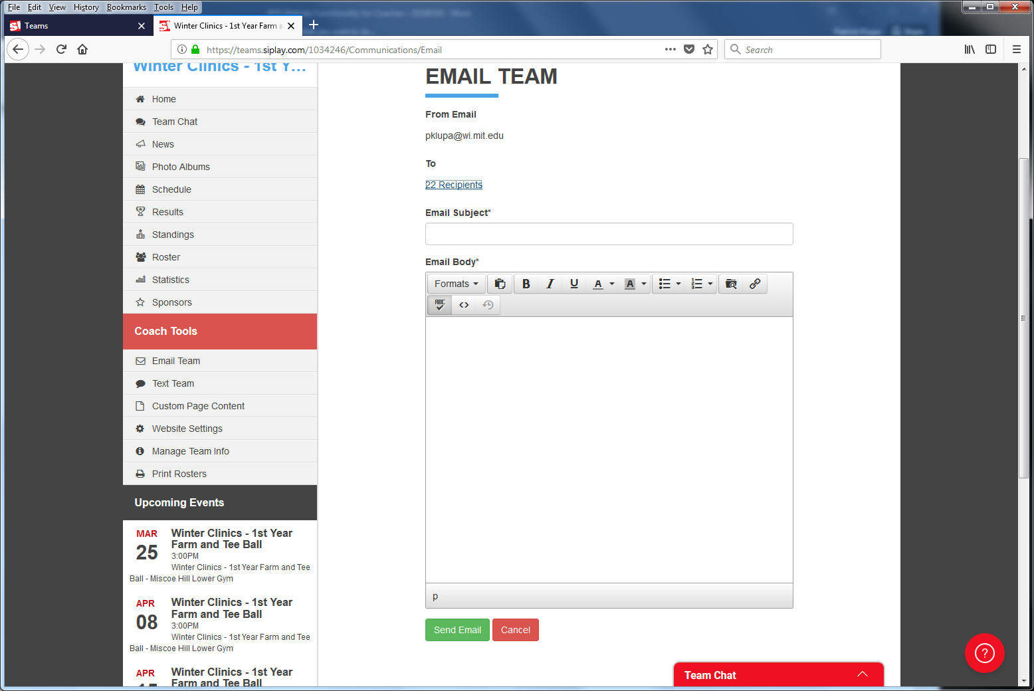

How to Add a Practice or Other Event to Your Schedule
- Go to the team website.
- Click the Schedule link on the left menu (circled below).
- A place to enter your schedule entry shown. Fill in all of the fields and indicate whether you want to notify the team.
- Click Save.
- Please note that you should let Patrick Klupa (NYS Website Coordinator) know if you need to add games. Patrick will ensure any new games are added properly so league scores & standings are recorded properly.
- You can always ask Patrick to add any practices or other events to your schedule.

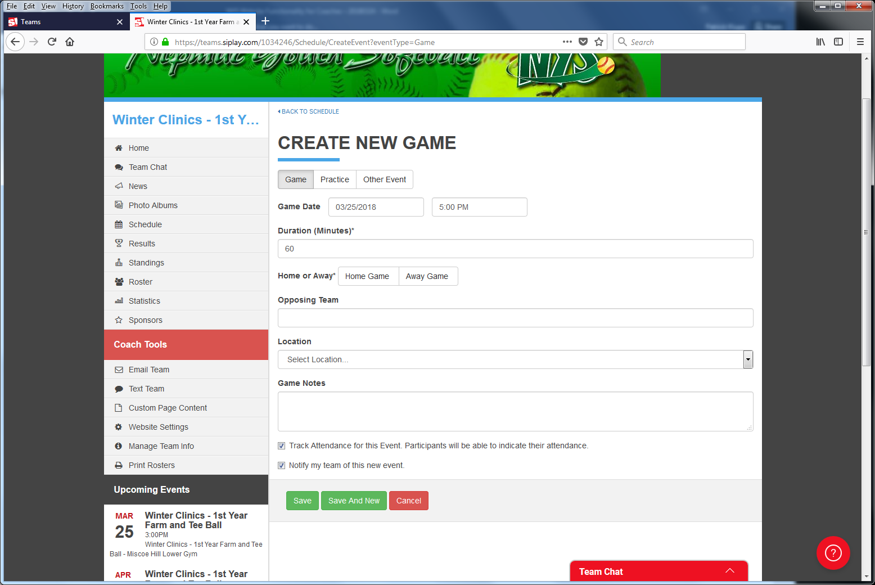

How to Monitor Attendance
There are two ways to monitor the attendance for your team for each event.

- Monitoring Attendance via the team website.
  - Go to the team website.
  - Click the Schedule link on the left menu (circled below).
  - Click the event’s down arrow to expand it.
  - Click the “See Full Even Details” button.
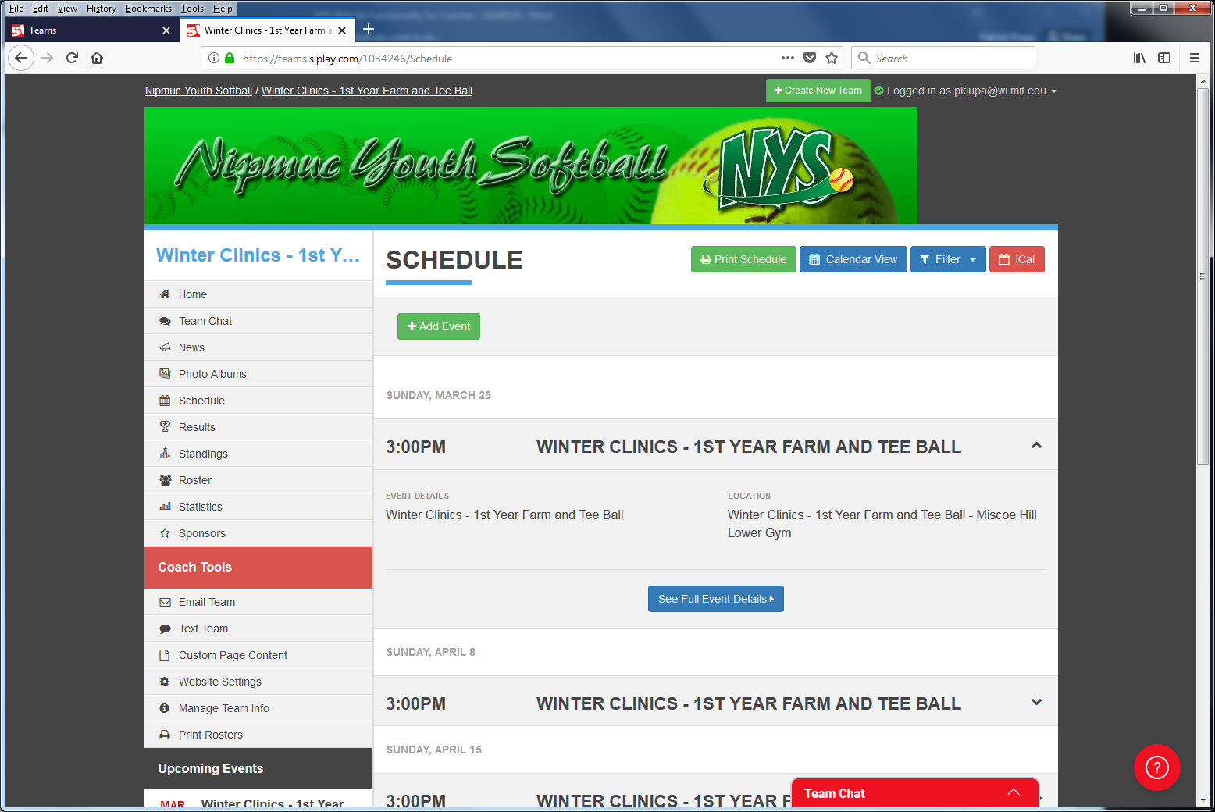
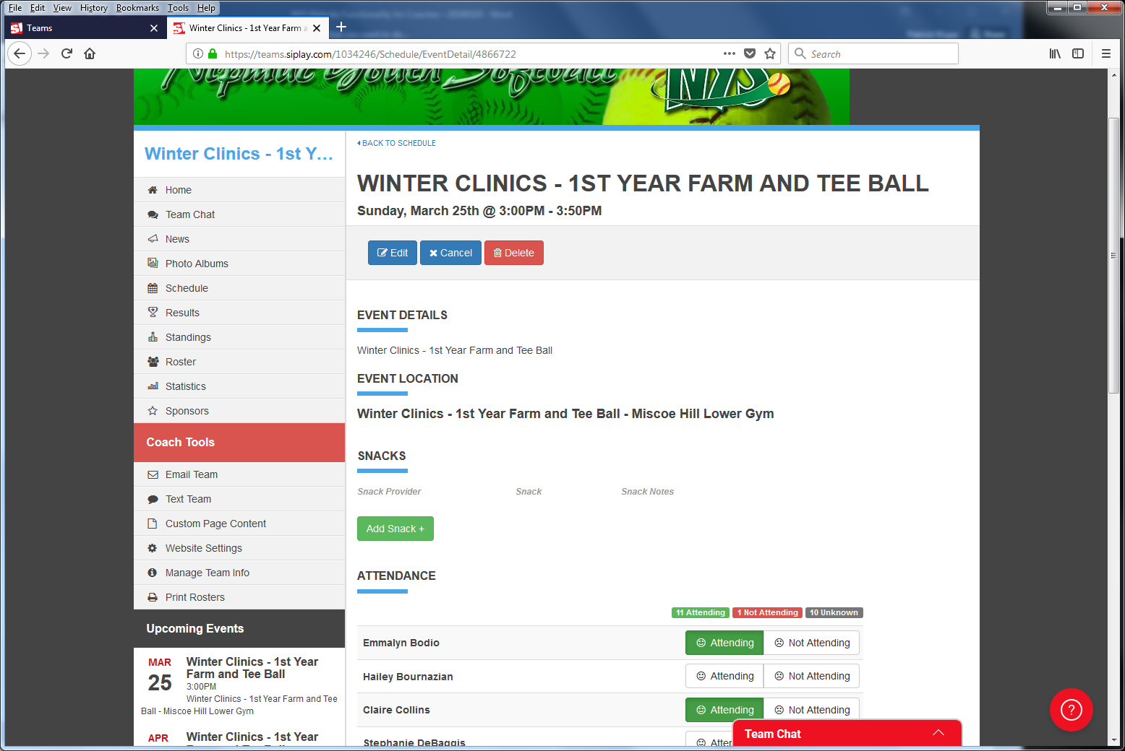
  - The event details are shown. Player statuses are shown at the bottom.

- Monitoring Attendance via the SI Play app.
  - Download and install the app.
  - Log into the app.
  - Click Schedule on the bottom bar.
  - Scroll to the event you are checking.
  - Click on the “three stick-figure player” icon in the lower right corner of the event box.
  - The number of players attending/not attending/not indicated are shown. You can scroll down the roster to see the status for each player.

Opting Into Texting
- Go to www.nipmucyouthsoftball.com.
- Click Login in the upper right corner and authenticate.
- You will be brought to a screen like #1 below.
- On the right side, click Account Settings to get to screen #2 below.
- On the right side, click Mobile Phone Settings to get to screen #3 below.
- Next to your mobile phone number, click Enable Texting.
- Then you will need to follow the instructions (receive a text with a code and put the code into the box on the screen).

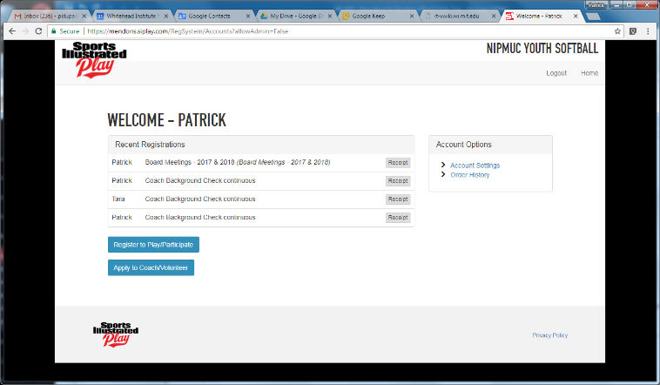

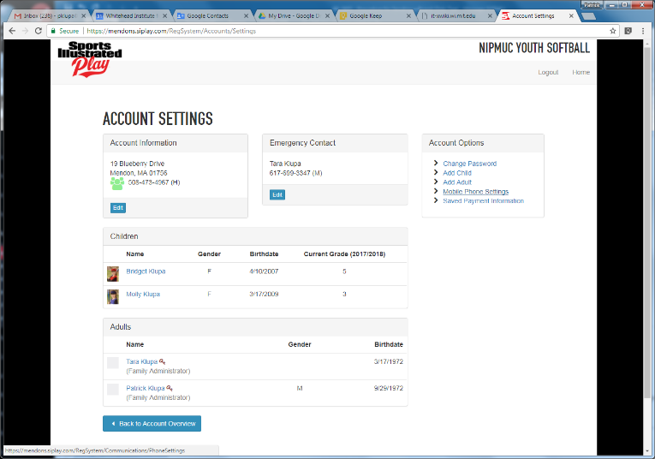

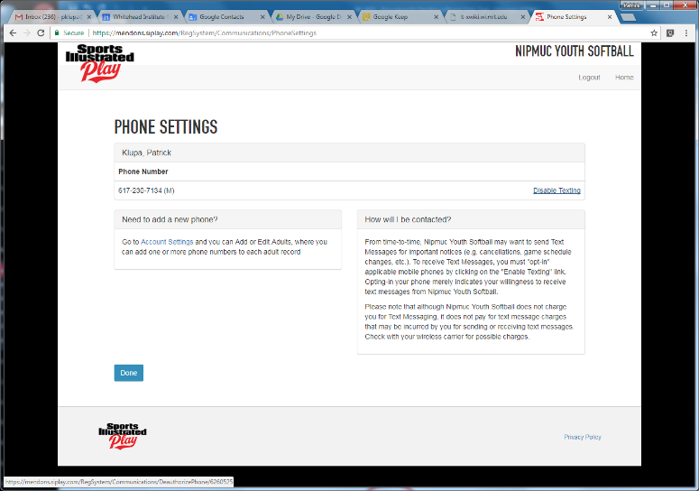

Electronic Scoring
Patrick Klupa has been using the iScore app to electronically record the play-by-play of NYS games. This is a completely free app that allows you to:
- Input the information you have on teams and players.
- Record the result of each pitch (ball, strike, foul, out, & in-play) during a game.
- Use a scatter chart to indicate where each hitter hits the ball to.

By tracking the detailed results of each pitch, you gain the following benefits:
- Can view statistics (game, season, life) of each player (your team and other teams).
- Can view the scatter chart of each batter to use for defensive positioning.
- Parents can “watch” the game online via a URL you give them (whether they are in the stands or not at the game).
- Can quickly produce box scores and spreadsheets of statistics.

Please see Patrick Klupa for more information on iScore. A user manual is available. It is easy to use, but requires practice to become proficient at using it during an actual game. Patrick recommends practicing with it first, such as by scoring a few innings of a baseball game on TV. Patrick also recommends that either an assistant coach or non-coaching parent take on the data entry during games.

