2019 Wee-Tee, T-Ball, Baseball Signups
SIGNUPS AT HIGHVIEW OFFICE BEHIND MOORE HIGH SCHOOL
SIGNUPS AT ACADEMY SPORTS
4901 OUTER LOOP

Saturday Feb. 2nd 10:00 am to 2:00 pm Saturday Feb. 9th 10:00 am to 2:00 pm Saturday Feb. 16th 10:00 am to 2:00 pm

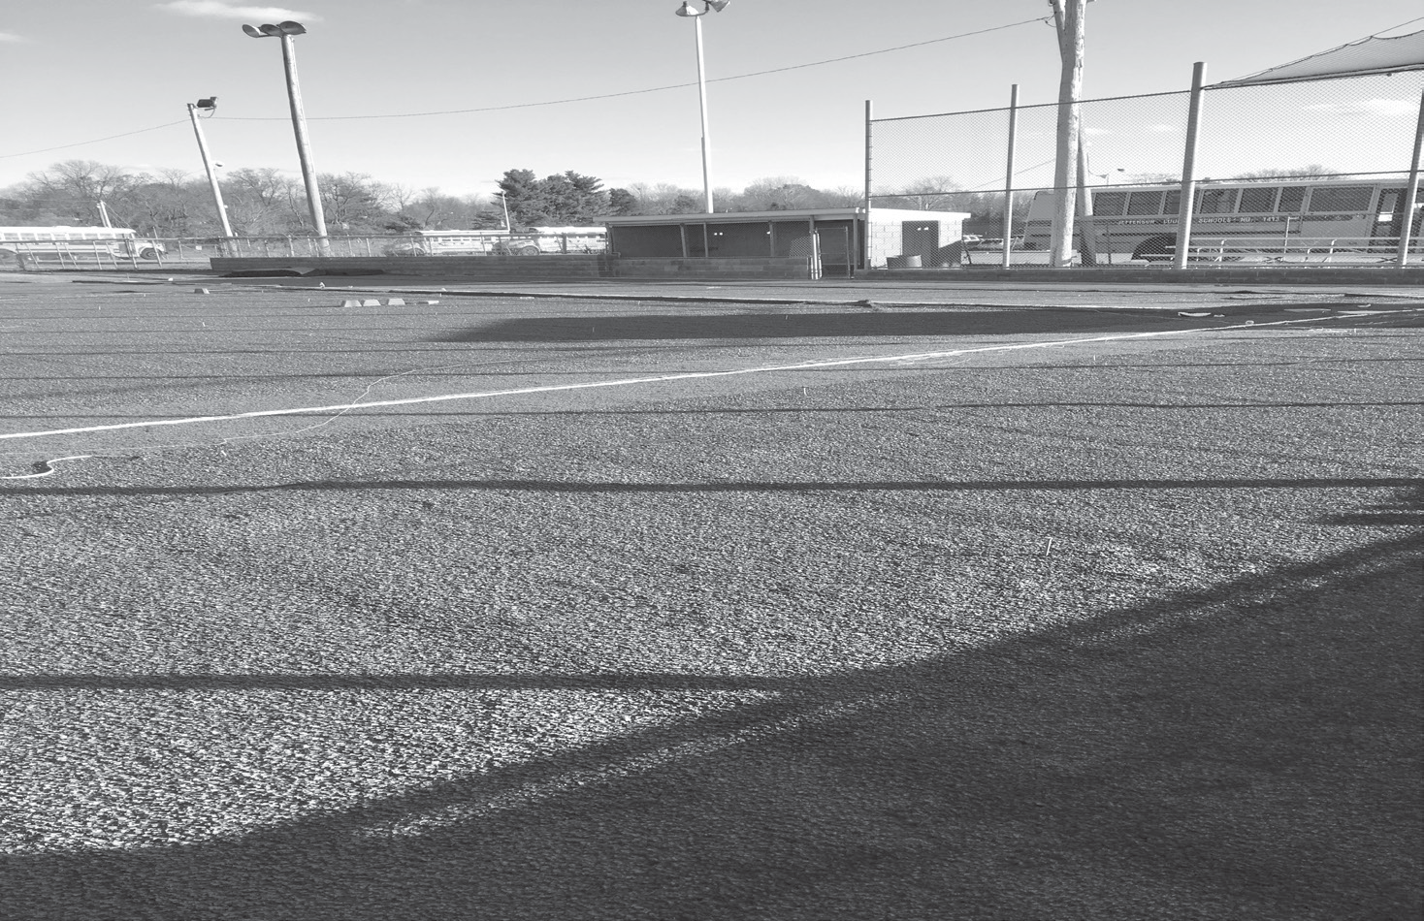
PLAYERS PLAY AT THE AGE THAT YOU WILL BE AS OF 4/30/19 AGES & COST:
Wee Tee AGES 3-4 $55 Tee Ball AGES 5-6 $55
(Age 6 is optional for tee ball or machine pitch)

MACHINE PITCH BASEBALL AGES 6-7-8 $70
(Age 6 is optional for tee ball or machine pitch)

BASEBALL-AGES 9-10 $70
BASEBALL-AGES 11-12 $70
BASEBALL-AGES 13-15 $70

There is a $10 discount per each additional player that resides in the same household.

EVERYONE SIGNING UP MUST BRING A BIRTH CERTIFICATE.
ALL PLAYERS AGE 6 AND OLDER (unless playing t-ball) MUST ATTEND A SKILLS EVALUATION.
VISIT OUR WEBSITE AT WWW.HIGHVIEWYOUTHSPORTS.COM AND JOIN US ON FACEBOOK
ALL PLAYERS ARE PLACED ON A TEAM
ANY QUESTIONS CALL 299-3380. LEAVE A MESSAGE AND WE WILL RETURN YOUR CALL.
VISIT OUR WEBSITE AT WWW.HIGHVIEWYOUTHSPORTS.COM AND JOIN US ON FACEBOOK

