  - 2018 Midwest plains babe ruth 13u regional tournament
July 25-29, 2018

chadron, nebraska
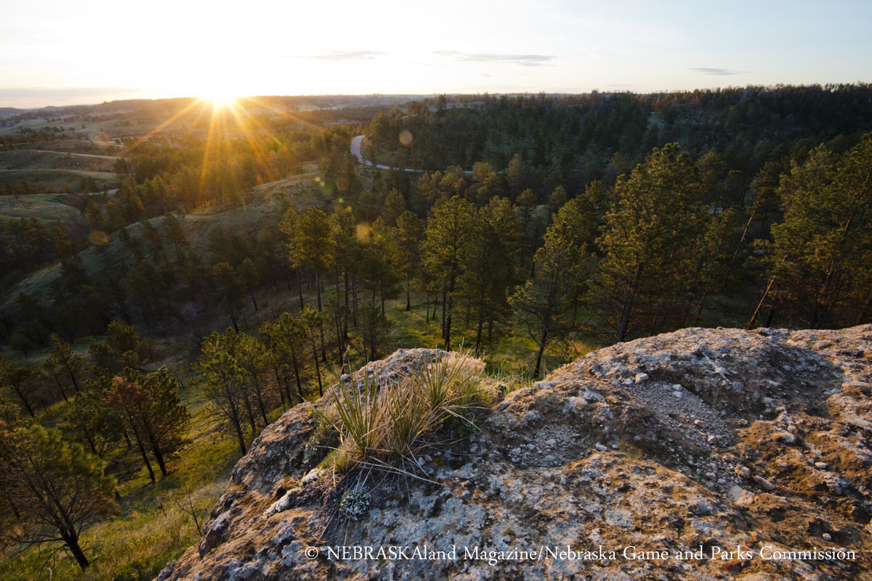
Table of Contents
Memo to Regional Tournament Managers
Tournament Events
Important Notes & Times
Picnic
Opening Ceremonies
Officials Meeting
Host Community
Directions
Tournament Contacts
Player Instructions
Additional Information & Schedule
MEMO TO REGIONAL TOURNAMENT MANAGERS
- Double check your tournament credential book and other appropriate information. Be sure that you have all required documents.
- Managers and Coaches: You will need to provide contact numbers for all coaches and managers and where you are staying, at check in. If there are changes to the schedule for games we will contact you at the numbers provided. We are NOT responsible if you do not answer and are late for games.
- Make sure you arrive at the check-in site as a complete team and at your designated time. Teams are to arrive and depart as a complete group. There will be NO exceptions, unless there has been prior approval from the Regional Commissioner. All such requests must be fully documented. Any player not excused and missing from check-in will not be allowed to participate in the tournament.
- The team players, manager and coaches are required to attend all official tournament events, including the welcome picnic and opening ceremonies. Managers and coaches are required to attend the “Managers and Coaches Meeting”.
- Any questions regarding any aspect of the tournament should be directed to the Babe Ruth Task Force Member in Charge.
- Remember that managers and coaches shall wear uniforms consistent with Babe Ruth Rules and have the Babe Ruth baseball patch on the left shoulder.
- Good sportsmanship makes the game enjoyable for everyone. Anyone acting in an unsportsmanlike manner will be removed from the playing field and facilities immediately.
- Be sure to have a team meeting and read through the Player’s Guide with your team! Be sure they know what is expected of them.
LIST OF REGIONAL TOURNAMENT EVENTS
Wednesday, July 25, 2018
Tournament Check-In times at the Chadron State College Student Center. Times subject to change – please confirm with tournament director upon your qualification. Teams must check in as a group, including: Managers, Coaches and Players. Please wear jerseys to check in. Tournament passes, shirts and souvenirs will be sold at check in.
TIME TEAM
11:30AM Chadron, NE (Host)
12:00PM Nebraska
12:30PM Colorado
1:00PM Iowa
1:30PM Kansas
2:00PM Missouri
2:30PM North Dakota
3:00PM Minnesota
5:30PM Tournament Picnic
6:30PM Opening Ceremonies
Tournament Picnic and Opening Ceremonies will be held at Maurice Horse Field in Chadron. All team managers, coaches, and players must attend.
LIST OF REGIONAL TOURNAMENT EVENTS (Continued)
Thursday, July 26, 2018
6:30AM All officials, coaches, managers, head umpire, state task force, and members of tournament committee are REQUIRED to attend. Breakfast will be served. Location TBA.
9:00AM – 6:30PM Pool Play, Day 1 (see schedule)
6:00PM - 9:00PM Bands on Bordeaux, located in downtown Chadron. Live music, food, drinks, and family activities. All are encouraged to attend, and players/teams will be recognized.
Friday, July 27, 2018
10:00AM – 8:00PM Pool Play, Day 2 (see schedule)
Saturday, July 28, 2018
10:00AM – 8:00PM Pool Play, Day 3 (see schedule)
Sunday, July 29, 2018
10:00AM - 5:00PM Single Elimination, Championship Bracket, Top 4 teams from Pool Play
IMPORTANT NOTES AND TIMES
Host Families – Each team will have a host family introduced to them at check-in. Please feel free to contact your host family with any questions about the tournament or our area during your stay.
State Flags – Please bring your state flag for display during Opening Ceremonies and the Tournament.

IMPORTANT NOTES AND TIMES (Continued)
Tournament Picnic – All coaches, managers and players must attend the picnic at Maurice Horse Field, Wednesday, July 25, 5:30pm. Players and coaches/managers eat for FREE. Families are also encouraged to attend, free will donation.
Opening Ceremonies – All coaches, managers and players MUST attend the Opening Ceremonies in FULL UNIFORM. Opening ceremonies will be held at Maurice Horse Field following the picnic on July 25, 6:30pm.
Officials Meeting – All officials, coaches, managers, head umpire, state task force members, and members of the tournament committee are REQUIRED to attend. The meeting will be held on Thursday, July 26, 6:30am, location TBA. Breakfast will be served.
Concessions – Concessions will be available at the ballpark. Water coolers will be provided in team dugouts. NO SMOKING OR ALCOHOL WILL BE ALLOWED IN THE BALL PARK OR THE CITY PARKS.
World Series Information – The winner of the Midwest Plains Regional 13U Tournament will be eligible to attend the Babe Ruth World Series Tournament in Mountain Home, Arkansas, August 9-16.
Directions to Maurice Horse Field – Maurice Horse Field is located on North Main Street. From the (stoplight) intersection of Highway 20/3rd Street and Main Street, travel north approximately 6 blocks.
Directions to Chadron State College Student Center – The CSC campus is located at the South end of Main Street. From the (stoplight) intersection of Highway 20/3rd Street and Main Street, travel South 7 blocks to 10th Street. From 10th Street and Main Street, turn left (East) and travel approximately 4 blocks. The Student Center sits immediately South of the clock tower.
TOURNAMENT CONTACTS
If you have any questions or need special assistance, please contact one of the following individuals:
Co-Tournament Directors:
Mike Provance Jen Brown
Vice President, Chadron Youth Baseball Secretary, Chadron Youth Baseball
PH: 308-430-2606 PH: 308-430-0225
Email: provancem@yahoo.com Email: jenniferleebrown3@gmail.com

Protest Committee:
Russ Bohnenkamp
Cell: 308-430-2003

Babe Ruth Official in Charge:
Steve Mracek
PH: 308-760-2523
Email: chops@bbcwb.net

Umpire in Chief:
Bruce Parish
PH: 308-430-8521

ADDITIONAL INFORMATION

Practice Fields – Contact the tournament director for available times and locations.

IMPORTANT – Tournament Program Pictures – Please e-mail your team picture with player names in the order they appear in the picture to Jen Brown at jenniferleebrown3@gmail.com. We encourage you to send your pictures ASAP.

Parents, Family and Fans – Parents, family and fans are invited, but not required, to attend check-in. Tournament souvenir shirts, programs and tournament passes will be available for purchase at check-in and at the tournament.

Pre-Game Information – Warm ups will be on one of the designated non-game areas. The home team shall use the third base dugout and visitors shall use the first base dugout. Home and visitor assignments will be determined by a coin flip. Be ready to play. There will be no warm ups on the game field. Turn line-ups into official scorekeepers by the 3rd inning of the game preceding yours.
Additional details will be covered at check-in and the officials meeting.

Gate Admission – The gate fees for the tournament will be as follows:

Pool Play Pass
Family (immediate family members) $60
Single $25
Day Pass $10

Championship Bracket Games
Adults/Students (5 and up) $5

Housing – No host family housing is provided for this tournament. Please visit the following website for a full list of area lodging options: http://discovernwnebraska.com/lodging/ .

Managers/Coaches Uniforms – The Manager and coaches must each have a jersey that matches the players (per Babe Ruth Rules).
ADDITIONAL INFORMATION (Continued)

Umpires – The umpires provided for this tournament have many years of experience working baseball. They will enforce all rules and regulations covered in the Official Babe Ruth Baseball Rule Book. Please treat them with respect at all times. Only the manager will be allowed to discuss an umpire’s decision or any play of a controversial nature. The home plate umpire will be informed of the identity of each team’s manager prior to the start of each game.

Sportsmanship – Any player, manager, coach, or fan acting in an unsportsmanlike manner will be removed from the playing field and facility immediately. Such behavior may also result in disqualification from the tournament.

Catcher’s Gear – Catchers are required to wear a mask/helmet during warm-ups both before and during the game. All coaches, managers, or players who warm up a pitcher either between innings or in the bullpen must wear a mask/helmet.

Batting Helmets – An approved batting helmet must be worn at bat, while running the bases, in the on-deck circle, and by any other player that might be coaching at first or third base. In addition, all bat persons must wear a batting helmet while on the playing field.

In the Dugouts and on the Field – Only players, managers, coaches, and bat persons will be allowed in each team’s dugout or on the field. Anyone in the dugout must be on the tournament roster, with the exception of any bat persons.

Equipment – Bats, gloves, balls and other equipment must be kept in the dugout, in the proper place and never kept on the field. Discarding of bats, helmets, gloves or any other items in an unsportsmanlike manner can result in ejection from the game.

Other Activities – If you have any questions about things to see and do during your visit to the Chadron area, do not hesitate to contact your Team
Representative or the Tournament Directors. We welcome you to our community!
