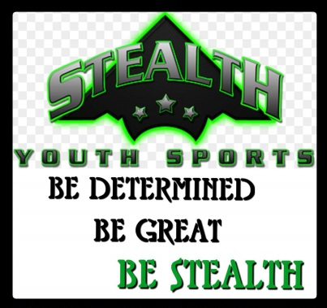

vhall@stealthsport.org

www.stealthsport.org

Sponsorship Options

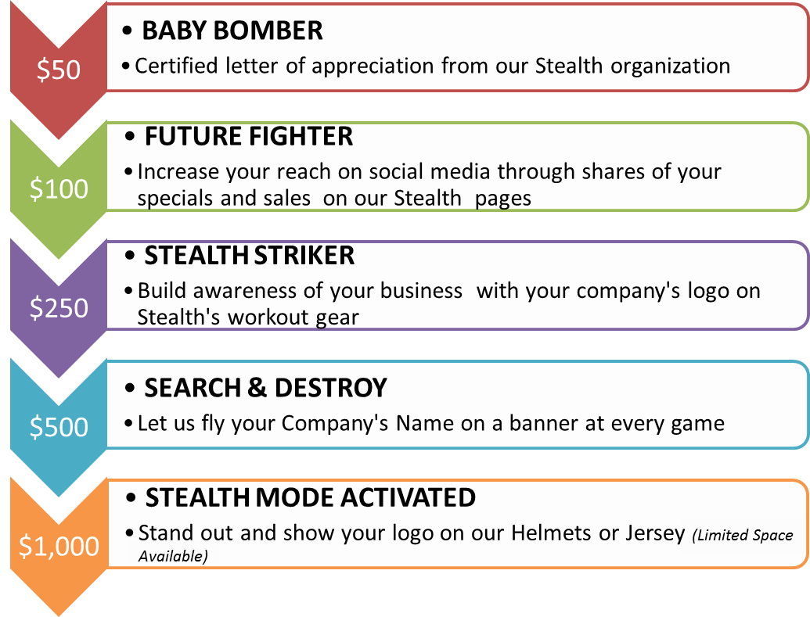
Sponsorship Agreement Form

Company Name (as you would like it to appear in advertising and on web site)
Point of Contact (Printed Name)/Authorized Signature
Company Mailing Address
Telephone | Email Address | Web Address
Baby Bomber Future Fighter Stealth Striker Search & Destroy __ Stealth Mode Activated __
Please contact Valarie Hall at vhall@stealthsport.org to discuss other opportunities.

Enclosed is our contribution of: $_______________________
Please make checks payable to: Stafford Stealth
Then return your completed form and check as soon as possible to:

Stealth Sports
Attn: Sponsorship Committee
P.O. Box 42
Hartwood, VA 22471
We appreciate your support and look forward to a great partnership for many years to come. If you have any questions, please don’t hesitate to contact us.

Valarie Hall Adam Conrath
Fundraising Coordinator President
(804) 366-4733 (540) 947-4117
vhall@stealthsport.org ajconrath@stealthsport.org

