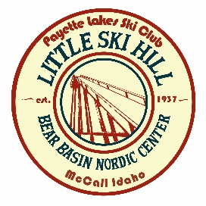
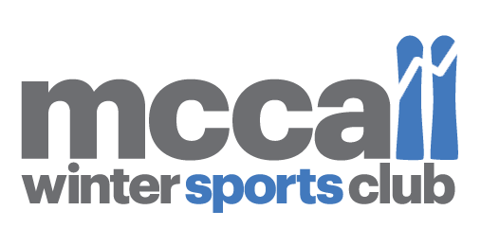
WAIVER AND RELEASE OF LIABILITY 2017 4 Way Race
(Please read and sign)
In consideration for the rights and privileges associated with participation in the 4 Way Race as a Member, or acting member of the McCall Winter Sports Club (MWSC), I acknowledge and agree to be bound by the following:
Identification of Risks.
I understand that my participation in any skiing activity including the 4 Way Race, involve risks of serious injury, including permanent disability, death and other losses, both to me and my property. I understand that these injuries and losses might result not only from my actions but the actions inactions or negligence of others.
Assumption of Risk.
I agree that I am responsible for my safety while participation in the Activity and that such responsibility includes participation in the Activity only: A: when I am both physically and psychologically prepared to participate safely, B: after fully familiarizing myself with the venue before beginning Activity, and C: while using the equipment of a type and condition reasonably necessary to safely participate in the Activity. I assume all the risks and responsibilities for any injury of loss connected with my participation in the Activity Waiver As the parent or guardian of the minor Member named above, I hereby make and enter into each and every agreement, representation, waiver and release described above on behalf of myself, the Member, and any other parent or guardian of the Member, intending that they be binding on me, the Member, and our respective heirs, executors, administrators and assigns. I intend to give up my right, the Members right, and the right of any other parent or guardian to maintain any claim or suit against the McCall Winter Sports Club (MWSC) or the Payette Lakes Ski Club (PLSC) arising out of the Member’s participation in any Activities involving MWSC and PLSC in any way. I believe and represent the I HAVE LEGAL AUTHORITY TO MAKE THESE AGREEMENTS, REPRESENTATIONS, WAIVERS AND RELEASES, AND I AGREE TO DEFEND AND INDEMNIFY MWSC and PLSC from and against any and all liability arising out of any lack of authority on my part to legally bind the Racer, or any unenforce-ability for any reason of the above agreements, representations, waivers and releases made by or on behalf of the Racer.
Insurance:
I currently have and agree to maintain throughout the time that I train and compete, valid and sufficient medical and accident insurance. I understand that this is my sole responsibility and release all persons and entities from providing this coverage for me. This is to certify that, as the participant or the parent/guardian of the above named minor; I do hereby acknowledge and consent to my or his/her agreement to be bound by each of the terms and conditions identified above.

SIGN HERE:
RACER’S SIGNATURE: _____________________________________ DATE: ________________________
RACER’S PRINTED NAME: ________________________________________________________________
PARENT/GUARDIAN (18 and Under) : __________________________________DATE: _______________
PARENT/GUARDIAN’S PRINTED NAME (18 and Under): ________________________________________
Medical Release: We do hereby authorize any licensed physician and/or responsible staff member of any hospital in any state to administer whatever medical treatment, or therapeutic procedures they deem necessary for the diagnosis and treatment of:
RACER’S SIGNATURE: ___________________________________________ DATE: __________________
RACER’S PRINTED NAME:________________________________________________________________
PARENT/GUARDIAN (18 and Under) : ________________________ DATE: ________________________
PARENT/GUARDIAN’S PRINTED NAME: _____________________________________________________

www.mccallwintersportsclub.org P.O. BOX 38 MCCALL, ID 83638

