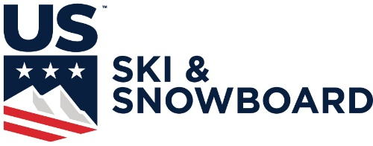
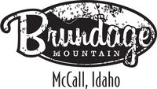

2018 Cranston Cup
Brundage Mountain, ID
February 24-25, 2018

Event: GS and SL: Stubbie (U10), tall pole (U12+)

Venue: Alpine

Schedule of Events: GS 2/24, SL 2/25

Age Groups: U10-U14 (U14+ age group must have 300+ USSA pts)

Entry Fees: $20 per race. $40 per series. Athletes must have a USSA Competitors license.

Entries: Email USSA Team Entry List and Coaches List to Shannon@bbsef.org

Entry Deadline: Wednesday, February 21st by 11:00pm

Waiver: All athletes must complete the McCall Winter Sports Club Waiver

Lift Tickets:
- Athlete Tickets $19/day.
- Parents can receive discounted tickets $54
- Coaches must submit the attached form for athlete tickets and must be included in team entry list to receive complimentary tickets at the team captains meeting.

Chief of Race: Matt Sylvester matty.sly@gmail.com 208-484-3473
Chief of Course: Justin Stoddard
Race Administrator: James Garrison
Technical Delegate: Jim Sund

Team Captain’s Meeting: Friday, February 23 7:30 pm Brundage Sales Office (401 S. 3rd Street, McCall)

Awards: 20 minutes after final racer at the Brundage base area.

Lodging Info:
InIdaho.com
Lodging Partner Specials
Indaho.com offers a Free booking service with a low-price guarantee and can book all area hotels, cabins and condos. Great rates at Third Street Inn, 15% off Super 8 and third night free off several cabins and condos in the McCall Area.

- Call toll free 800 844 3246
- Email vacations@inidaho.com,
- Online booking and live chat at www.inidaho.com

McCall Vacation Rentals - Mccallidahovacationrentals.com, tel:(208)473-9368

