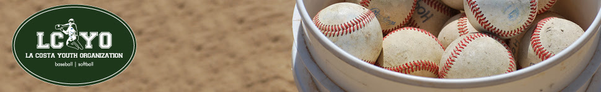

TEAM MANAGERS – HOW TO ORDER TICKETS FOR PETCO PONY DAY

USA Softball Day at Petco Park is on Saturday, April 14th. The Padres are taking on the San Francisco Giants and we’re all invited! We had record-breaking attendance again last year, so please make sure your team knows about this opportunity as soon as possible.
Softball players and coaches have the unique opportunity to participate in a pre-game parade. Softball teams will sit together in the stadium in an upper section behind home plate this year. This is the single largest fundraiser for LCYO, so please invite family, neighbors, and friends! This will be a great day out at the ballpark for all baseball fans!
Tickets are only $25. All forms and money (one form per team) must be submitted to Megan Biehl by SATURDAY, MARCH 31st.
Team Parents, please write a check with each family’s name on it for any cash collected or request only checks from your team. Cash is impossible to track in the case of missing orders or tickets. Checks can be made out to LCYO. LCYO will send out USA Softball Day email reminders to families as the event approaches.
There will be a PIZZA PARTY AND A $100 GIFT CARD for the softball team that sells the most tickets!
Getting your paperwork to LCYO:
Please drop off your paperwork to Kerry Vara’s home (see below: gray LCYO drop box) with check payment IN AN ENVELOPE (Please don’t leave loose checks in the box) marked with:
- SOFTBALL
- Team Parent Name & Phone Number
- Division (T-Ball, Pinto, etc.)
- Team Name

EXAMPLE: SOFTBALL Megan Biehl 760-814-3777 8U Orange Crush
Once the tickets are ready, LCYO will contact you the week of APRIL 9th and let you know when you can pick them up. You will be responsible for distributing individual tickets to your team. There will be an envelope with “SOFTBALL,” your Team Name, Division and your name on it in the same box where you dropped off your order. Thanks for your help and for volunteering with LCYO!
***NEW TICKET DROP OFF/PICK-UP LOCATION***
Kerry Vara – Baseball Team Parent Director
6820 Xana Way, Carlsbad 92009

Please direct any specific USA Softball Day questions to Megan Biehl at 760-814-3777 nednmeg@gmail.com

