Are You a Helpful or Harmful Softball Parent?This Sharing Buttons
Share to TwitterTwitterShare to FacebookFacebookShare to EmailEmailShare to PrintFriendlyPrintFriendly
Every softball team has parents, but not all softball parents’ behaviors are helpful. Here’s a way for your parents to ensure their actions are helping their daughters.
There’s a fine line between caring about your daughter’s softball efforts and caring too much. Help can turn to harm so make sure your parents know the signs.
Parenting is hard. I don’t know any parent who would deny that. All parents start out with good intentions for their daughter’s softball efforts and gradually, and sometimes unnoticeably those efforts shift over to the harmful side. I don’t mean that a parent’s actions are physically harming their child, but rather, their intentions of helping their child have become counter-productive.
What started out as trying to enable their daughter has turned into overdoing and is now disabling her. Help has turned into Hurt, and good intentions have gone bad. I don’t believe that parents do this purposefully, but they do it myopically. That is to say, their behavior is so single-handedly focused on only their daughter that they easily overlook she’s playing in a team sport that involves lots of other daughters.
Help is a funny thing. We do it out of love and good intentions. And while it starts out being a kind gesture for the recipient, it can quickly turn into coddling. I do it with my Mom. If you’ve followed me long, you’re aware of my Mom. She’s 89 and still an adventurer. She drives cross-country by herself (still). She drives the “old people” to church. She gardens every day, and she’s always active. She’s definitely NOT your typical 89-year-old.
But to me, I see her getting older. She has bad arthritis so she uses a cane and sometimes has trouble getting up and down, so I try to help her – all the time! My actions are out of love and good intentions, but it’s annoying as can be to my Mom because in her words, “Cindy, I can do it myself!” My intentions of helping her have crossed over into the “disabling her” world – except she’s not a child, so she can fully notice it, and let me know about it.
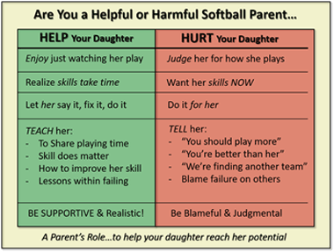
Daughters, on the other hand, aren’t in the position of authority to let a parent know what started out as love and kindness has now crossed over into “disabling her”. Kids often like to have adults do things for them if they’re feeling lazy, but for the most part, just like my Mom, kids want to do things themselves – even if they go a little wrong at first. There’s a sense of power that comes with doing something yourself.
Whenever I do something for my Mom, I take the power away from her, and whenever your parents do or say things for their daughters, they remove their daughter’s power as well.
So, here’s a quick way for all the parents on your softball team to look at their behavior and see if their actions are empowering or dis-powering their daughters – if they’re helping or hurting them.

