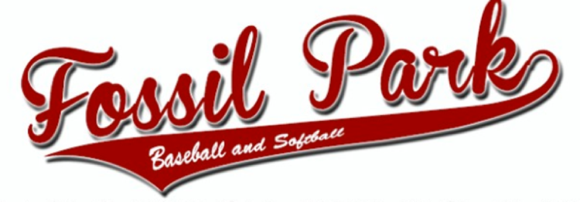
Sportsmanship * Teamwork * Integrity * Commitment

Fossil Park Youth Baseball and Softball, Inc.
6801 Dr. Martin Luther King Jr. St. N., Saint Petersburg, FL 33702
(727) 525-6155 www.fossilparkbaseball.org

SPONSORSHIP AGREEMENT
Organization Name: ___________________ Contact Name: ___________________
Phone: ___________________ Email: ___________________
Address: ___________________ City, State, Zip: ___________________
Web Site: ___________________ Preferred Team Baseball ___ or Softball ____

___ Banner Sponsor
Banner at park, Logo on Fossil Park website,
Price: $300 per season, or $500 for both Fall and Spring seasons

___ Team Sponsor
Banner Sponsor details above, PLUS
Name on back of jerseys for one team
Price: $400 per season

___ Batting Cage Sponsor Naming Sponsor (ONE AVAILABLE)
Banner on batting cages
Batting cages referred to as “[SPONSOR] Batting Cages” on internal schedules and emails
Price: $1,000 per season

___ Field sponsor
Three banners (one in/around infield and one on outfield fence)
Price: $600 per season

___ Field Naming Sponsor (FOUR AVAILABLE, one per field)
Two Banner on field (infield and outfield)
Field referred to as '(SPONSOR) Field' on all internal schedules and emails
Price: $1,000 per season

Signature: ________________________
Date: ________________________

Please email your artwork to fossilparkbaseballsoftball@gmail.com so we can print your banner.

