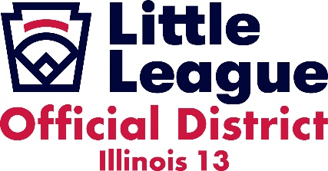
Little League Illinois District 13 has established the following COVID-19 mitigation guidelines for all District 13 Little Leagues. These guidelines are the minimum mitigation guidelines and are to be followed throughout all local leagues in Illinois District 13. These mandates reflect those currently in place by the Illinois Department of Public Health and protocols established by Little League International. The Illinois Department of Public Health mandates are listed in red. Mitigation protocols established by Little League International are in black.
- Participants. Participants are identified as coaches, players, umpires, and team volunteers actively participating in the event.
  - All non fully vaccinated participants much wear face coverings during the event. This includes all players, coaches, umpires, and volunteers actively participating in the event who have not been fully vaccinated.
    - ATHLETES DO NOT NEED TO WEAR A FACE COVERING WHILE COMPETING ON THE PLAYING FIELD.
    - A medical exemption will be made for participants who have a note from a doctor explaining the medical exemption.
      - The original doctors note needs to be filed with player’s local little league board.
        - Coaches should carry an electronic copy of the doctor’s note as proof of the exemption.
        - The team manager must show proof of the exemption to the head umpire officiating the game and show the opposing team’s manager.
    - Exception: In order to mitigate potential heat related injuries, If the heat Index exceeds 82° degrees Fahrenheit the local league will determine if heat injury prevention protocols are to be enacted. These protocols will include that unvaccinated athletes may be unmasked when off the field provided the following protocols are in place.
      - Players in the dugout are limited to the spatial capacity needed to maintain social distancing of 6 feet.
      - The overflow of players are seated behind the dugout or backstop and are spaced 6 feet apart.
      - Unvaccinated managers and coaches must wear a face covering when breaching the 6 feet social distancing while interacting with an athlete or volunteer.
- Spectators.
  - Spectators who are not fully vaccinated are to wear face coverings when walking around the park.
- Additional mitigation protocols must be adhered to at the local league and team level.
  - Every league will establish a player quarantine area away from heavy foot traffic for any players who exhibit COVID-19 symptoms.
    - The players must remain in the quarantine area while maintaining social distance of 6 feet until they are picked up by their parent or guardian.
  - Managers and coaches must ask each of their players how they feel prior to the start of each practice or game. If COVID-19 symptoms are identified or recent exposure is discovered, the player must be moved to the designated quarantine area immediately.
  - Parents and coaches should be informed if any participant has been recently exposed to or has exhibited any symptoms of COVID-19. Local Leagues will follow their local county’s reporting guidelines while also following the local league’s internal reporting and tracking procedures. A COVID-19 “self checker” is available on the Center for Disease Control website. Local leagues can implement their own COVID-19 certification procedures for their participants prior to arrival of events.
  - The District Administrator and District Safety officer must be notified by the local league of any incident involving a participant or participants needing to be quarantined as well as any positive COVID-19 test.

